**Setting Up Chef-Server on Ubuntu 14.04 Server**

**(2 VCPU – 4 GB RAM – 40 GB Disk)**

##### **Step 1: Update your repo**

# apt-get update

**Step 2 :Install NTP**

# apt-get install ntp -y

##### **Step 3: Download Chef-Server core**

# wget https://packages.chef.io/files/stable/chef-server/12.17.33/ubuntu/16.04/chef-server-core_12.17.33-1_amd64.deb

##### **Step 4: Install Chef-Server core Once the download is complete, install the package by typing:**

# dpkg -i chef-server-core_12.17.33-1_amd64.deb

Your output should look like below

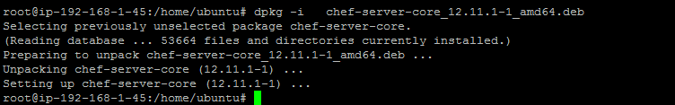

##### **Step 5: Configure Chef-Server Once the installation is complete, you must call the reconfigure command, which configures the components that make up the server to work together in your specific environment:**

# chef-server-ctl reconfigure

|  |  |
| --- | --- |
| Chef Manage | Use Chef management console to manage data bags, attributes, run-lists, roles, environments, and cookbooks from a web user interface. |

# Installing the web UI

The web UI is now a premium feature of Chef Server. It is not installed by default. To install the web UI on your Chef Server, run the following commands to install the opscode-manage plugin and reconfigure both the web UI configuration and the Chef Server configuration to use the web UI:

chef-server-ctl install chef-manage

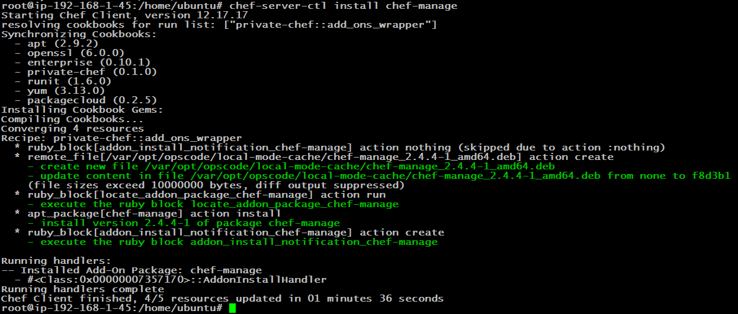

**then:**

**$ chef-server-ctl reconfigure**

**and then:**

**$ chef-manage-ctl reconfigure**

**Press Enter**

**Press q**

**Type “yes” and hit enter**

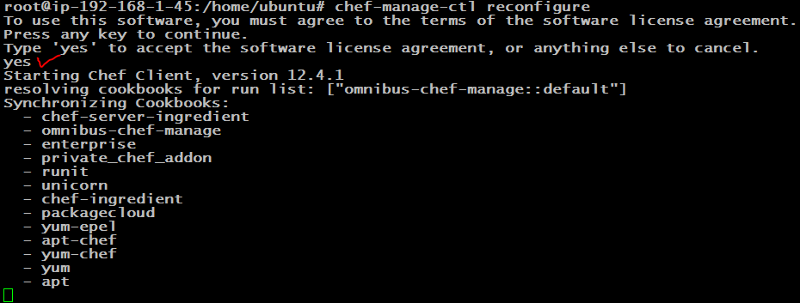

**Now open your hostname on web browser and you should see the dashboard**

